Chapter 5 Facelets
1. Facelets Tags

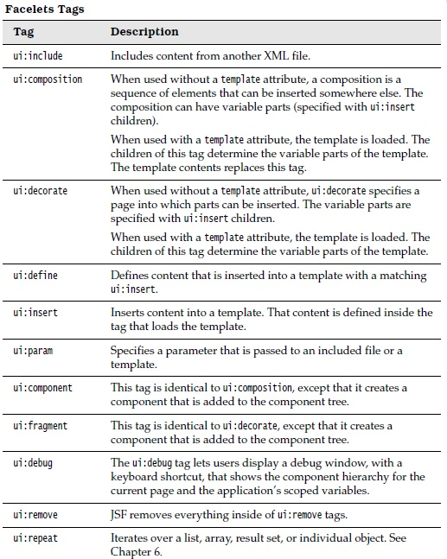

2. Templating with Facelets <ui:insert>, <ui:composition> and <ui:define>
- Most of the websites will be have pages with similar layout and styling. They have common header, footer and sidebars etc.
- Facelets lets you encapsulate that commonality in a template, so that one can update the site by making changes to template than individual pages.
- Template Example
<ui:insert>
<ui:composition>
<ui:define>

- Lets have TemplatePjt directory as shown below

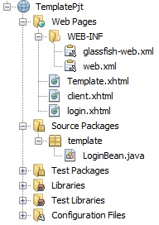

web.xml
<?xml version="1.0" encoding="UTF-8"?>
<web-app xmlns:xsi="http://www.w3.org/2001/XMLSchema-instance" xmlns="http://java.sun.com/xml/ns/javaee" xsi:schemaLocation="http://java.sun.com/xml/ns/javaee http://java.sun.com/xml/ns/javaee/web-app_3_0.xsd" version="3.0">
<display-name>TemplateProject</display-name>
<servlet>
<servlet-name>Faces Servlet</servlet-name>
<servlet-class>javax.faces.webapp.FacesServlet</servlet-class>
<load-on-startup>1</load-on-startup>
</servlet>
<servlet-mapping>
<servlet-name>Faces Servlet</servlet-name>
<url-pattern>/faces/*</url-pattern>
</servlet-mapping>
<context-param>
<description>State saving method: 'client' or 'server' (=default). See JSF Specification 2.5.2</description>
<param-name>javax.faces.STATE_SAVING_METHOD</param-name>
<param-value>client</param-value>
</context-param>
<context-param>
<param-name>javax.servlet.jsp.jstl.fmt.localizationContext</param-name>
<param-value>resources.application</param-value>
</context-param>
<listener>
<listener-class>com.sun.faces.config.ConfigureListener</listener-class>
</listener>
<welcome-file-list>
<welcome-file>Login.xhtml</welcome-file>
</welcome-file-list>
</web-app>

login.xhtml
<?xml version="1.0" encoding="ISO-8859-1" ?>
<!DOCTYPE html PUBLIC "-//W3C//DTD XHTML 1.0 Strict//EN" "http://www.w3.org/TR/xhtml1/DTD/xhtml1-strict.dtd">
<html xmlns="http://www.w3.org/1999/xhtml"
xmlns:c="http://java.sun.com/jsf/core"
xmlns:ui = "http://java.sun.com/jsf/facelets"
xmlns:h = "http://java.sun.com/jsf/html">

<h:body>
<h:form>
Enter name : <h:inputText id="name" value="#{LoginBean.name}"/>
<h:commandButton id="submit" value="submit" action="client"/>
</h:form>
</h:body>
</html>

template.xhtml

<?xml version="1.0" encoding="ISO-8859-1" ?>
<!DOCTYPE html PUBLIC "-//W3C//DTD XHTML 1.0 Strict//EN" "http://www.w3.org/TR/xhtml1/DTD/xhtml1-strict.dtd">
<html xmlns="http://www.w3.org/1999/xhtml"
xmlns:c="http://java.sun.com/jsf/core"
xmlns:ui = "http://java.sun.com/jsf/facelets"
xmlns:h = "http://java.sun.com/jsf/html">

<h:body>
<ui:insert name="message"/>
</h:body>
</html>

client.xhtml

<?xml version="1.0" encoding="ISO-8859-1" ?>
<!DOCTYPE html PUBLIC "-//W3C//DTD XHTML 1.0 Strict//EN" "http://www.w3.org/TR/xhtml1/DTD/xhtml1-strict.dtd">
<html xmlns="http://www.w3.org/1999/xhtml"
xmlns:c="http://java.sun.com/jsf/core"
xmlns:ui = "http://java.sun.com/jsf/facelets"
xmlns:h = "http://java.sun.com/jsf/html">

<h:body>
<h:form>
<ui:composition template = "/template.xhtml">

<ui:define name = "message">
Hello #{LoginBean.name}
</ui:define>

</ui:composition>
</h:form>
</h:body>
</html>

Output
login.xhtml

client.xhtml

- Facelets removes all tags outside the ui:composition tag—that is, the doctype declaration, html, head, title, and body tags. This is necessary because the ui:composition is replaced with the template that contains its own set of html, head, title, and body tags.
- When the template is loaded, each ui:insert is replaced with the contents of the corresponding ui:define.

3. Decorators <ui:decorate>
- With decorators first content is designed and then decorated using <ui:decorate> tag.
- <ui:decorate> tag has 'template' attribute and it can be used in the place of <ui:composition>.
- Difference between <ui:composition> and <ui:decorate> is, anything outside <ui:composition> tag is disregarded but its not true with <ui:decorate>. Hence <ui:decorate> is beneficial as template-in-template.

4. Parameters <ui:param>
- In a template one can supply argument in two ways. One is through <ui:define> and other is through <ui:param>.
- While <ui:define> provides markup that inserted into the template, In constrast <ui:param> sets an EL variable for use in template.
- Ex
<ui:composition template="templates/masterTemplate.xhtml">
<ui:param name="currentDate" value="#{someBean.currentDate}"/>
</ui:composition>

In the corresponding template, you can access the parameter with an EL
expression, like this:
...
<body>
Today's date: #{currentDate}"/>
</body>
…

- Ex
Lets create a 'uiparam' project directory as shown below

header.xhtml
<?xml version="1.0" encoding="UTF-8"?>
<!DOCTYPE html PUBLIC "-//W3C//DTD XHTML 1.0 Transitional//EN"
"http://www.w3.org/TR/xhtml1/DTD/xhtml1-transitional.dtd">
<html xmlns="http://www.w3.org/1999/xhtml"
xmlns:ui="http://java.sun.com/jsf/facelets">
<body>
<ui:composition>
<h1>#{defaultHeader}</h1>
</ui:composition>
</body>
</html>

footer.xhtml
<?xml version="1.0" encoding="UTF-8"?>
<!DOCTYPE html PUBLIC "-//W3C//DTD XHTML 1.0 Transitional//EN"
"http://www.w3.org/TR/xhtml1/DTD/xhtml1-transitional.dtd">
<html xmlns="http://www.w3.org/1999/xhtml"
xmlns:ui="http://java.sun.com/jsf/facelets">
<body>
<ui:composition>
<h1>#{defaultFooter}</h1>
</ui:composition>
</body>
</html>

common.xhtml
<?xml version="1.0" encoding="UTF-8"?>
<!DOCTYPE html PUBLIC "-//W3C//DTD XHTML 1.0 Transitional//EN"
"http://www.w3.org/TR/xhtml1/DTD/xhtml1-transitional.dtd">
<html xmlns="http://www.w3.org/1999/xhtml"
xmlns:h="http://java.sun.com/jsf/html"
xmlns:ui="http://java.sun.com/jsf/facelets">
<h:head></h:head>
<h2>#{title}</h2>
<h:body>
<div style="border-width:2px; border-color:yellow; border-style:solid;">
<ui:insert name="header" >
<ui:include src="/templates/header.xhtml" >
<ui:param name="defaultHeader" value="Default Header" />
</ui:include>
</ui:insert>
</div>
<br/>
<div style="border-width:2px; border-color:black; border-style:solid;">
<ui:insert name="content" >
<ui:include src="/templates/contents.xhtml" />
</ui:insert>
</div>
<br/>
<div style="border-width:2px; border-color:red; border-style:solid;">
<ui:insert name="footer" >
<ui:include src="/templates/footer.xhtml">
<ui:param name="defaultFooter" value="Default Footer" />
</ui:include>
</ui:insert>
</div>
</h:body>
</html>

home.xhtml
<?xml version="1.0" encoding="UTF-8"?>
<!DOCTYPE html PUBLIC "-//W3C//DTD XHTML 1.0 Transitional//EN"
"http://www.w3.org/TR/xhtml1/DTD/xhtml1-transitional.dtd">
<html xmlns="http://www.w3.org/1999/xhtml"
xmlns:h="http://java.sun.com/jsf/html"
xmlns:ui="http://java.sun.com/jsf/facelets">
<h:body>
<ui:composition template="templates/common.xhtml">
<ui:param name="title" value="Home" />
<ui:define name="content">
<br/><br/>
<h:link value="Page 1" outcome="page1" />
<h:link value="Page 2" outcome="page2" />
<br/><br/>
</ui:define>
</ui:composition>
</h:body>
</html>

web.xml
<?xml version="1.0" encoding="UTF-8"?>
<web-app version="3.1" xmlns="http://xmlns.jcp.org/xml/ns/javaee" xmlns:xsi="http://www.w3.org/2001/XMLSchema-instance" xsi:schemaLocation="http://xmlns.jcp.org/xml/ns/javaee http://xmlns.jcp.org/xml/ns/javaee/web-app_3_1.xsd">
<context-param>
<param-name>javax.faces.PROJECT_STAGE</param-name>
<param-value>Development</param-value>
</context-param>
<servlet>
<servlet-name>Faces Servlet</servlet-name>
<servlet-class>javax.faces.webapp.FacesServlet</servlet-class>
<load-on-startup>1</load-on-startup>
</servlet>
<servlet-mapping>
<servlet-name>Faces Servlet</servlet-name>
<url-pattern>/faces/*</url-pattern>
</servlet-mapping>
<session-config>
<session-timeout>
30
</session-timeout>
</session-config>
<welcome-file-list>
<welcome-file>faces/home.xhtml</welcome-file>
</welcome-file-list>
</web-app>

Output

Note : Page1 and Page2 view pages has not been implemented and only kept to enable links.

- Here we can see how <ui:param> in two ways
I. As child tag with <ui:include> both for header and footer in common.xhtml file.
Ex <ui:param name="defaultHeader" value="Default Header" />
ii. As child tag with <ui:composition> for title
<ui:param name="title" value="Home" />

5. Components and Fragements <ui:component> and <ui:fragement>
- <ui:component> tag is similar to <ui:composition> except for two things
I. JSF creates a separate component for it and adds it directly to the component tree.
ii. There is no associated template.
- <ui:component> tag is used to create component and specify a file name for the component as either the source of a <ui:include> ( as done in the following example) or the source of a Facelets tag.
- <ui:compostion> is used to define template layout but <ui:component> is encapsulate definition of a facelet component.
- It has id, binding and rendered attribute. If 'binding' attribute has been used then one can programmatically

manipulate the component.
- Also one can conditionally render the component by setting 'rendered' attribute to a value expression(which is a boolean value). If its false then component is not rendered in the page.
- Any markup occurring outside of the <ui:component> tag is not included in the view.
- Similarly <ui:fragement> is same as <ui:component> it only includes tags occurring outside itself.

6. <ui:debug> tag
- If <ui:debug> tag added to a facelet page then a debug component will be added to the component tree of that page.
- If user types hotkey, which is by default CTRL+SHIFT+d, the JSF open a window and displays the state of the component tree and applicatoin's scoped variables.
- One can change the hotkey using attribute 'hotkey'
Ex <ui:debug hotkey=”i”/>
then the hotkey becomes CTRL+SHIFT+i.
- Ex uses <ui:component>, <ui:fragement>, <ui:debug>
Lets create project directory for project 'uicompNfrag' as shown below

header.xhtml
<?xml version="1.0" encoding="UTF-8"?>
<!DOCTYPE html PUBLIC "-//W3C//DTD XHTML 1.0 Transitional//EN"
"http://www.w3.org/TR/xhtml1/DTD/xhtml1-transitional.dtd">
<html xmlns="http://www.w3.org/1999/xhtml"
xmlns:ui="http://java.sun.com/jsf/facelets">
<body>
<div style="width:100%;line-height:48px;background-color:#336699;color:white; font-size:30px">
JSF Facelets Application</div>
</body>
</html>

footer.xhtml
<?xml version="1.0" encoding="UTF-8"?>
<!DOCTYPE html PUBLIC "-//W3C//DTD XHTML 1.0 Transitional//EN"
"http://www.w3.org/TR/xhtml1/DTD/xhtml1-transitional.dtd">
<html xmlns="http://www.w3.org/1999/xhtml"
xmlns:ui="http://java.sun.com/jsf/facelets">
<head>
<meta http-equiv="Content-Type" content="text/html; charset=ISO-8859-1" />
<title>Insert title here</title>
</head>
<body>
<div style="background-color: #336699; width: 100%; color: #FFFFFF">@copyright,RISK soft</div>
</body>
</html>

sideMenu.xhtml
<?xml version='1.0' encoding='UTF-8' ?>
<!DOCTYPE html PUBLIC "-//W3C//DTD XHTML 1.0 Transitional//EN" "http://www.w3.org/TR/xhtml1/DTD/xhtml1-transitional.dtd">
<html xmlns="http://www.w3.org/1999/xhtml"
xmlns:ui="http://java.sun.com/jsf/facelets"
xmlns:h="http://java.sun.com/jsf/html"
xmlns:c="http://xmlns.jcp.org/jsp/jstl/core">
This text will not be rendered.<br/>
<ui:component id="comp">
<c:forEach var="menu" items="#{menuBackingBean.menus}">
<a href="#{menu.url}">#{menu.label}</a><br/>
</c:forEach>
</ui:component>
</html>

insertTemplate.xhtml
<!DOCTYPE html PUBLIC "-//W3C//DTD XHTML 1.0 Transitional//EN" "http://www.w3.org/TR/xhtml1/DTD/xhtml1-transitional.dtd">
<html xmlns="http://www.w3.org/1999/xhtml"
xmlns:ui="http://java.sun.com/jsf/facelets"
xmlns:h="http://java.sun.com/jsf/html">
<head>
<title>Facelets example</title>
</head>
<body >
<div style="border-bottom: grey 2px solid; border-left: grey 2px solid; border-right: grey 2px solid; border-top: grey 2px solid; height: 100%; margin: 4px auto; text-align: center; width: 100%;">
<ui:insert name="header">
<ui:include src="/templates/header.xhtml" />
</ui:insert></div>
<table width="100%" >
<tr>
<td width="20%">
<div style="height: 250px; width: 100%; background-color: #e0e0e0; text-align: center;">
<br></br>
<ui:insert name="sidemenu"/>

</div>
</td>
<td width="85%">
<ui:insert name="content">Content displayed from Template </ui:insert>
</td>
</tr>
</table>
<div style="border-bottom: grey 2px solid; border-left: grey 2px solid; border-right: grey 2px solid; border-top: grey 2px solid; height: 100%; margin: 4px auto; text-align: center; width: 100%;">
<ui:insert name="footer">
<ui:include src="/templates/footer.xhtml" />
</ui:insert></div>
<ui:debug hotkey="i"/><!--hotkey is placed here -->
</body>
</html>

home.xhtml
<!DOCTYPE html PUBLIC "-//W3C//DTD XHTML 1.0 Transitional//EN"
"http://www.w3.org/TR/xhtml1/DTD/xhtml1-transitional.dtd">
<html xmlns="http://www.w3.org/1999/xhtml"
xmlns:ui="http://java.sun.com/jsf/facelets"
xmlns:h="http://java.sun.com/jsf/html"
xmlns:f="http://java.sun.com/jsf/core">
<ui:composition template="templates/insertTemplate.xhtml">
<ui:define name="sidemenu">
<ui:include src="sideMenu.xhtml" />
</ui:define>
<ui:define name="content">
This is an example of a simple Facelets template.<br/>
Here Header and Footer appears from template.(inserTemplate.xhtml)<br/>
Side Menu appears from sideMenu.xhtml<br/>
This section appears from templateClient.(home.xhtml)
</ui:define>
</ui:composition>
</html>

MenuItem.java
package com.compnfrag;

public class MenuItem {
private String url;
private String label;
public String getUrl() {
return url;
}
public void setUrl(String url) {
this.url = url;
}
public String getLabel() {
return label;
}
public void setLabel(String label) {
this.label = label;
}
public MenuItem() {
super();
}
public MenuItem(String url, String label) {
super();
this.url = url;
this.label = label;
}
}

MenuBackingBean.java
package com.compnfrag;

import java.io.Serializable;
import java.util.ArrayList;
import java.util.Collection;
import javax.enterprise.context.SessionScoped;
import javax.inject.Named;

@Named("menuBackingBean")
@SessionScoped
public class MenuBackingBean implements Serializable {
private Collection<MenuItem> menus;
public Collection<MenuItem> getMenus() {
return menus;
}
public void setMenus(Collection<MenuItem> menus) {
this.menus = menus;
}
public MenuBackingBean() {
super();
menus = new ArrayList<>();
menus.add(new MenuItem("home.xhtml", "Home"));
menus.add(new MenuItem("news.xhtml", "News"));
menus.add(new MenuItem("articles.xhtml", "Articles"));
menus.add(new MenuItem("about.xhtml", "About Us"));
}
}

web.xml
<?xml version="1.0" encoding="UTF-8"?>
<web-app version="3.1" xmlns="http://xmlns.jcp.org/xml/ns/javaee" xmlns:xsi="http://www.w3.org/2001/XMLSchema-instance" xsi:schemaLocation="http://xmlns.jcp.org/xml/ns/javaee http://xmlns.jcp.org/xml/ns/javaee/web-app_3_1.xsd">
<context-param>
<param-name>javax.faces.PROJECT_STAGE</param-name>
<param-value>Development</param-value>
</context-param>
<servlet>
<servlet-name>Faces Servlet</servlet-name>
<servlet-class>javax.faces.webapp.FacesServlet</servlet-class>
<load-on-startup>1</load-on-startup>
</servlet>
<servlet-mapping>
<servlet-name>Faces Servlet</servlet-name>
<url-pattern>/faces/*</url-pattern>
</servlet-mapping>
<session-config>
<session-timeout>
30
</session-timeout>
</session-config>
<welcome-file-list>
<welcome-file>faces/home.xhtml</welcome-file>
</welcome-file-list>
</web-app>

Output
1. Without <ui:component> tag
When <ui:component> tag is commented out inside sideMenu.xhtml as shown below
This text will not be rendered.<br/>
<ui:component id="comp">
<c:forEach var="menu" items="#{menuBackingBean.menus}">
<a href="#{menu.url}">#{menu.label}</a><br/>
</c:forEach>
</ui:component>

home.xhtml

Debug
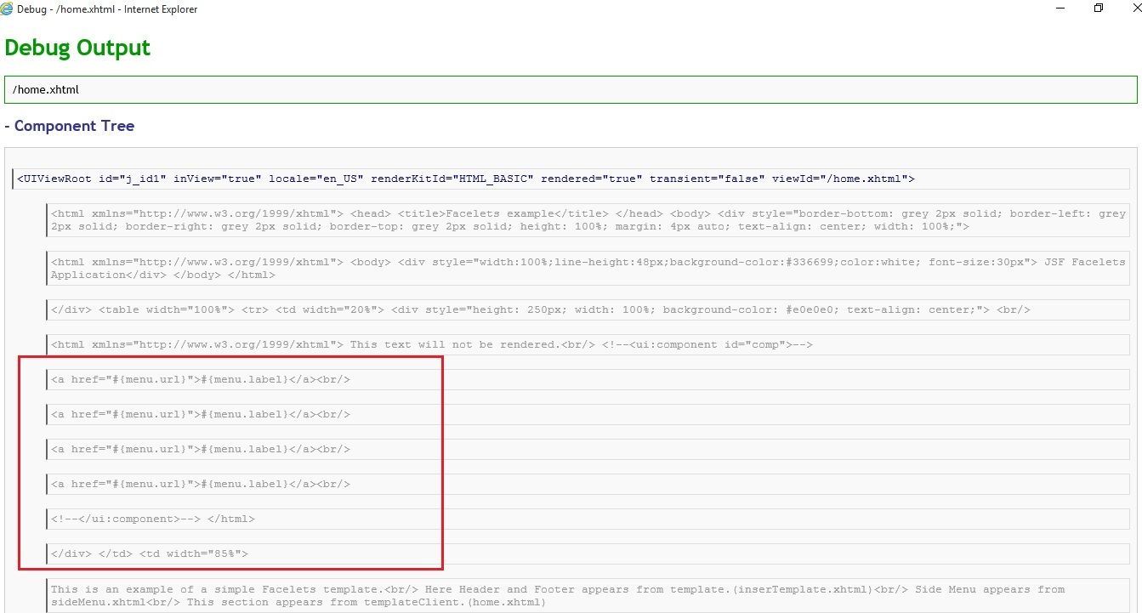
Note : Above we can see as <ui:component> tag is commented out they content of sideMenu.xhtml has appeared with other contents and not as separate component.

2. With <ui:component> tag
This text will not be rendered.<br/>
<ui:component id="comp">
<c:forEach var="menu" items="#{menuBackingBean.menus}">
<a href="#{menu.url}">#{menu.label}</a><br/>
</c:forEach>
</ui:component>

home.xhtml

Debug
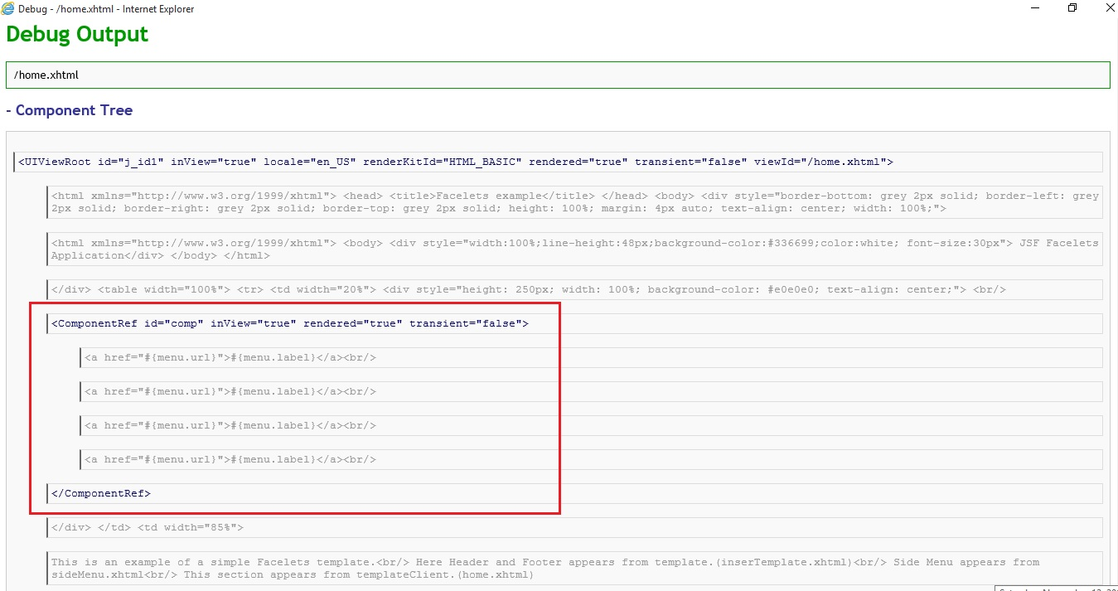
Note: Here we can note that <ui:component> is seen as a separate component in debug window.

3. With <ui:fragement>
Lets replace <ui:component> in sideMenu.xhtml with <ui:fragement> tag as shown below
<ui:fragement id="comp">
<c:forEach var="menu" items="#{menuBackingBean.menus}">
<a href="#{menu.url}">#{menu.label}</a><br/>
</c:forEach>
</ui:fragement>
home.xhtml(same as without component)
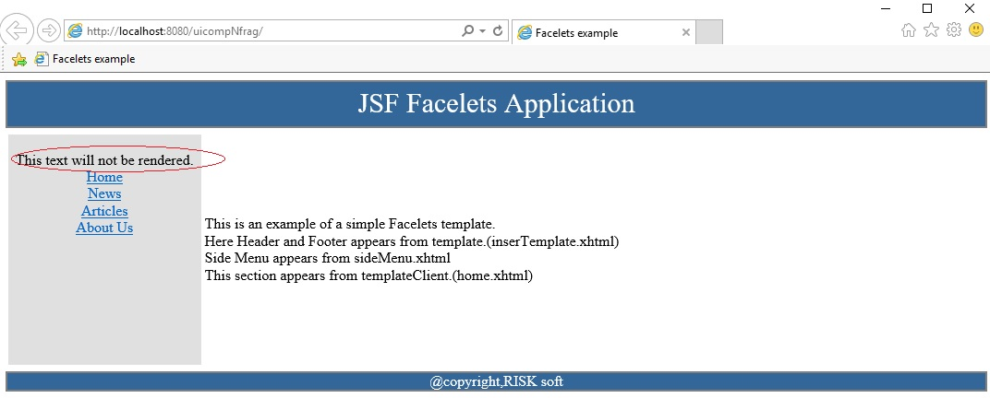
Note: Here contents outside <ui:fragement> is also got displayed.

Debug(Same as with Component)
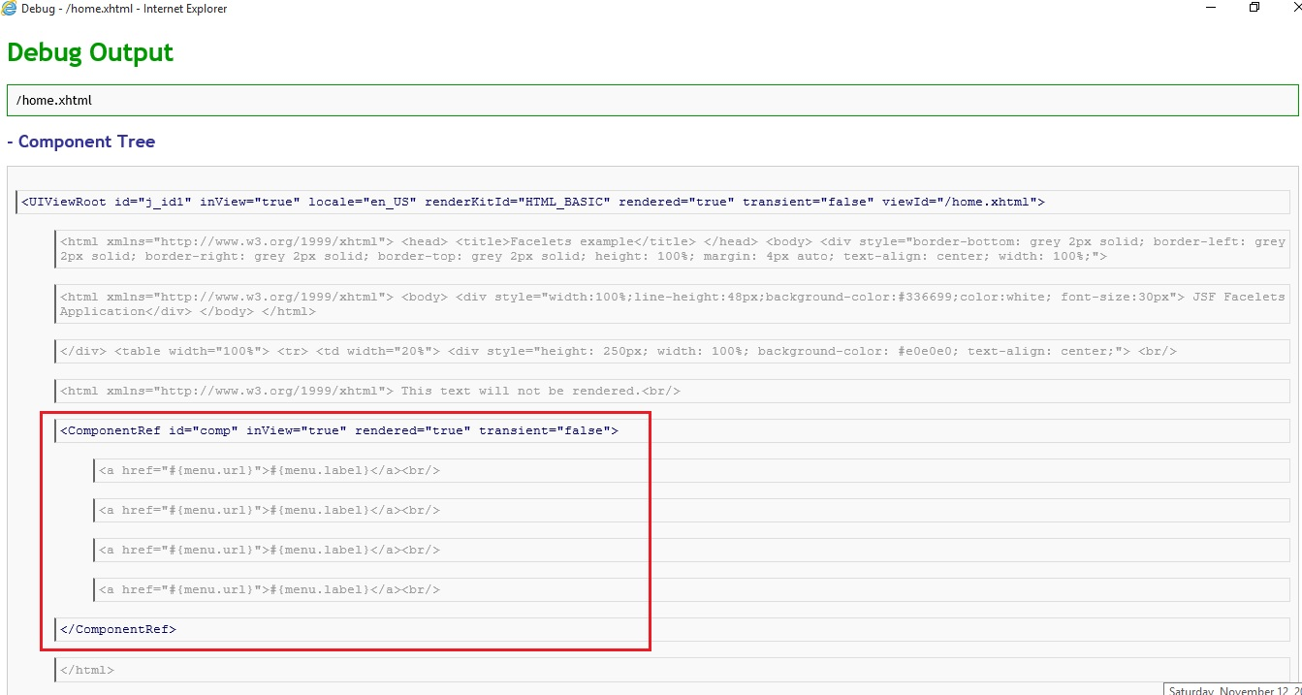

7. <ui:remove> tag
- <ui:remove> removes content from a page i.e. dont render content.
- XML comment <!-- --> will not be useful as if it contains a 'value expression' then that will be rendered.
Ex
<!-- <h:commandButton id="loginButton"
value="#{msgs.loginButtonText}"
action="planetarium"/> -->
will be rendered as
<!-- <h:commandButton id="loginButton"
value="Log In"
action="planetarium"/> -->
and if loginButtonText method will throw an exception then it will be a problem. Hence <ui:remove> is the best solution.
- If in above example we use <ui:remove> inside sideMenu.xhtml as shown below
This text will not be rendered.<br/>
<ui:remove>
<c:forEach var="menu" items="#{menuBackingBean.menus}">
<a href="#{menu.url}">#{menu.label}</a><br/>
</c:forEach>
</ui:remove>

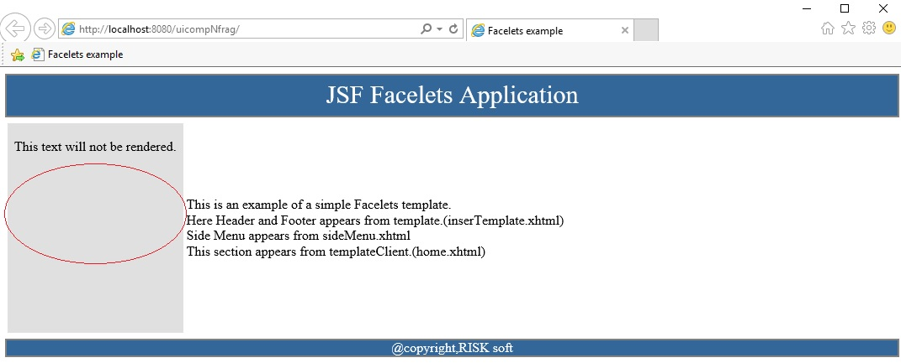
8. Handling Whitespace
- Be default in JSF white spaces are trimmed around components. For example
<h:outputText value="#{msgs.name}"/>
<h:inputText value="#{user.name}"/>
Here above two will be separated by white space. The facelets wont turn that white space into the text component.
- But same is not true for two links in a row
<h:commandLink value="Previous" .../> <h:commandLink value="Next" .../>
This will turn into PreviousNext. Hence to provide white space one use value expression with a space #{' '}.

